How to Join a Zoom Meeting – step by step
Either:
- click on the Zoom link you may have been provided with (it will look something like this: https://otago.zoom.us/j/123456789)
Or
- Go to https://otago.zoom.us/join and Enter the Meeting ID that you have been provided with in the appropriate field and click ‘Join’ (the Meeting ID will be a 9 or 10 digit number)
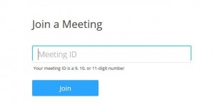
If joining from a mobile Device
If you are joining from a mobile device (Android smartphone/tablet, Apple iPhone/iPad) then it will simply prompt you to download the Zoom Cloud Meetings app from the App/Play Store.
See here for more details
The Zoom App to install for an iPhone or iPad looks like this:
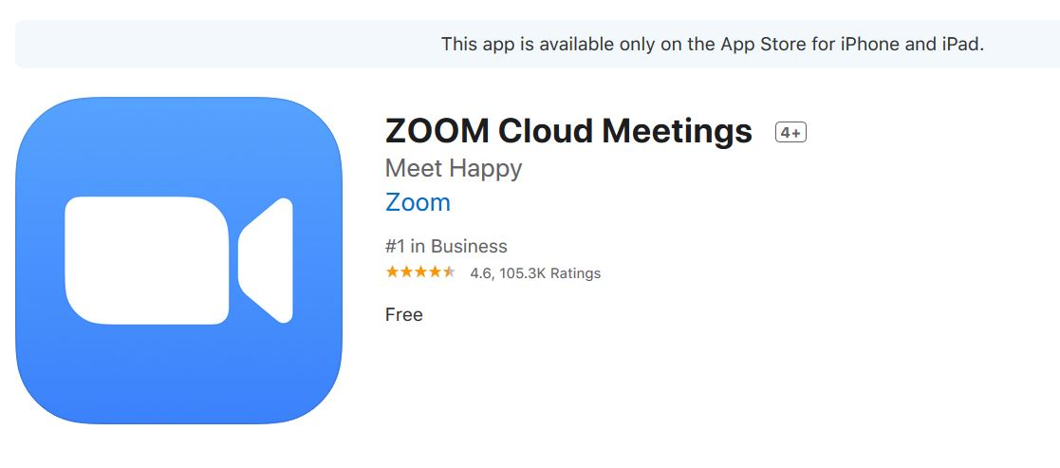
The App on Google Play to download looks like this:
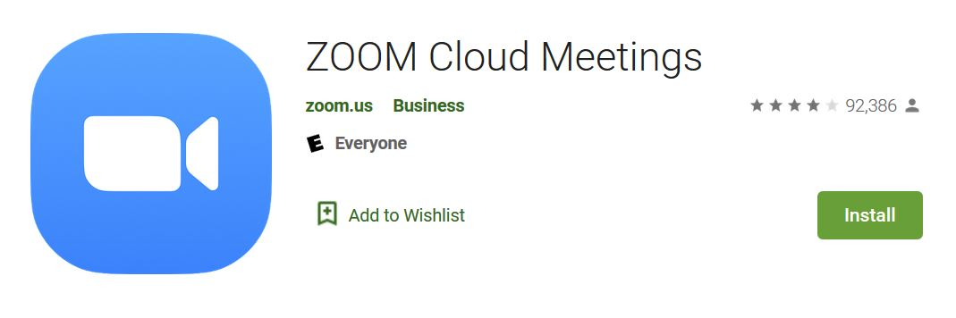

If joining from a computer
PLEASE NOTE: When entering a Zoom meeting for the first time from a computer you will need to download a small application file.
The examples below are shown using Mozilla Firefox and Google Chrome.
Mozilla Firefox
Click ‘Save File’ and follow the instruction in the orange box.
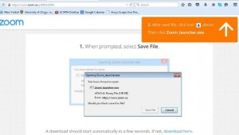

Google Chrome
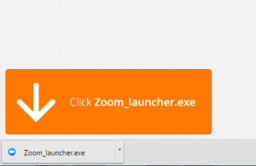
Google Chrome should automatically download the file and point to it as shown above. Clicking on the Zoom_launcher.exe file will install Zoom, there will be a short pause before a blue progress bar appears indicating the installation.
If an ‘Application Launcher’ or ‘External Protocol Request’ box appears simply tick the ‘Remember my choice…’ option box and then click ‘OK’
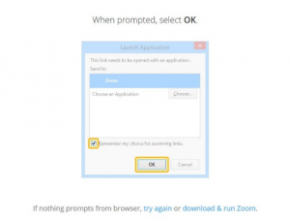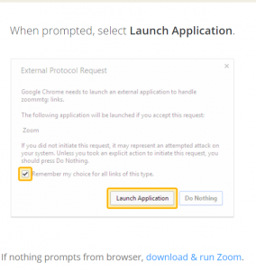

Just Before Entering The Meeting: You will be prompted to enter a display name. This name is simply to identify you in the meeting.
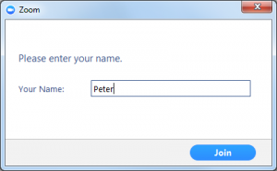
Join Audio via Computer
You will then be prompted how you wish to join your audio. If you wish to join audio via the telephone, follow the instructions further down, otherwise simply select Join Computer by Audio
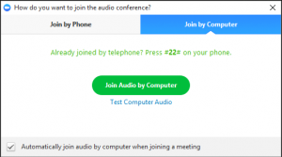
Join via Telephone
If you are unable to join from Zoom on a computer or mobile device, then you can join on the telephone instead.
If you would like to attend a Zoom meeting via telephone within NZ please call the NZ number (check this link for up to date numbers https://zoom.us/zoomconference). Then enter the Meeting ID and PIN (if required) when prompted.
There are also many “local” dial-in numbers from many international locations. You can find more details on these here.

Join via Computer & Audio via Telephone
It is possible to use a combination of computer for video and phone for audio.
If you use this option, then enter by computer first and select the Join By Phone tab when the audio pop-up window appears (see example below). This will display the NZ dial in number for you (or you can change it to display one of the many other countries which have a “local” dial in number by clicking on the flag icon), as well as the Meeting ID to enter and your Participant ID.
Dial in as noted above, however after entering the Meeting ID, you will be prompted to enter your Participant ID. Simply enter this number followed by # and your video and audio will then be synchronised.
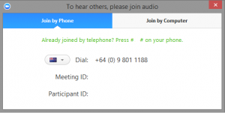

Raising Your Hand
As the non-speaker if you wish to ask a question or make a point during a meeting it is good protocol to use the ‘Raise Hand’ facility.
If the tool bar is not showing at the bottom of the Zoom window, place your cursor over the Zoom window so it appears and select the ‘Participants’ icon.
A window listing other participants will appear, there is also a ‘Raise Hand’ icon, click the icon to make it known to the Host that you would like to raise your hand.
If you wish to lower your hand, click the ‘Lower hand’ icon that will have replaced the ‘Raise hand’ icon.
Using Chat
You can use the ‘Chat’ facility to send text chat to all participants or privately to specific participants.
Click on the ‘Chat’ icon in the tool bar, again hover your mouse over the Zoom window if you can’t see the tool bar.
A chat window will then open. Select ‘Everyone’ or the name of the person you wish to send a chat message to.
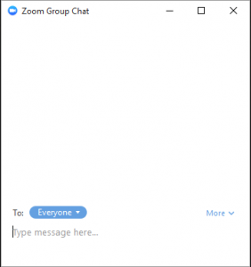
Audio only
It is possible that during the conference participants will be asked to turn off their cameras and move to audio only, particularly if there are problems with the available bandwidth.
To do this simply click on the camera icon at the bottom of the Zoom window.

