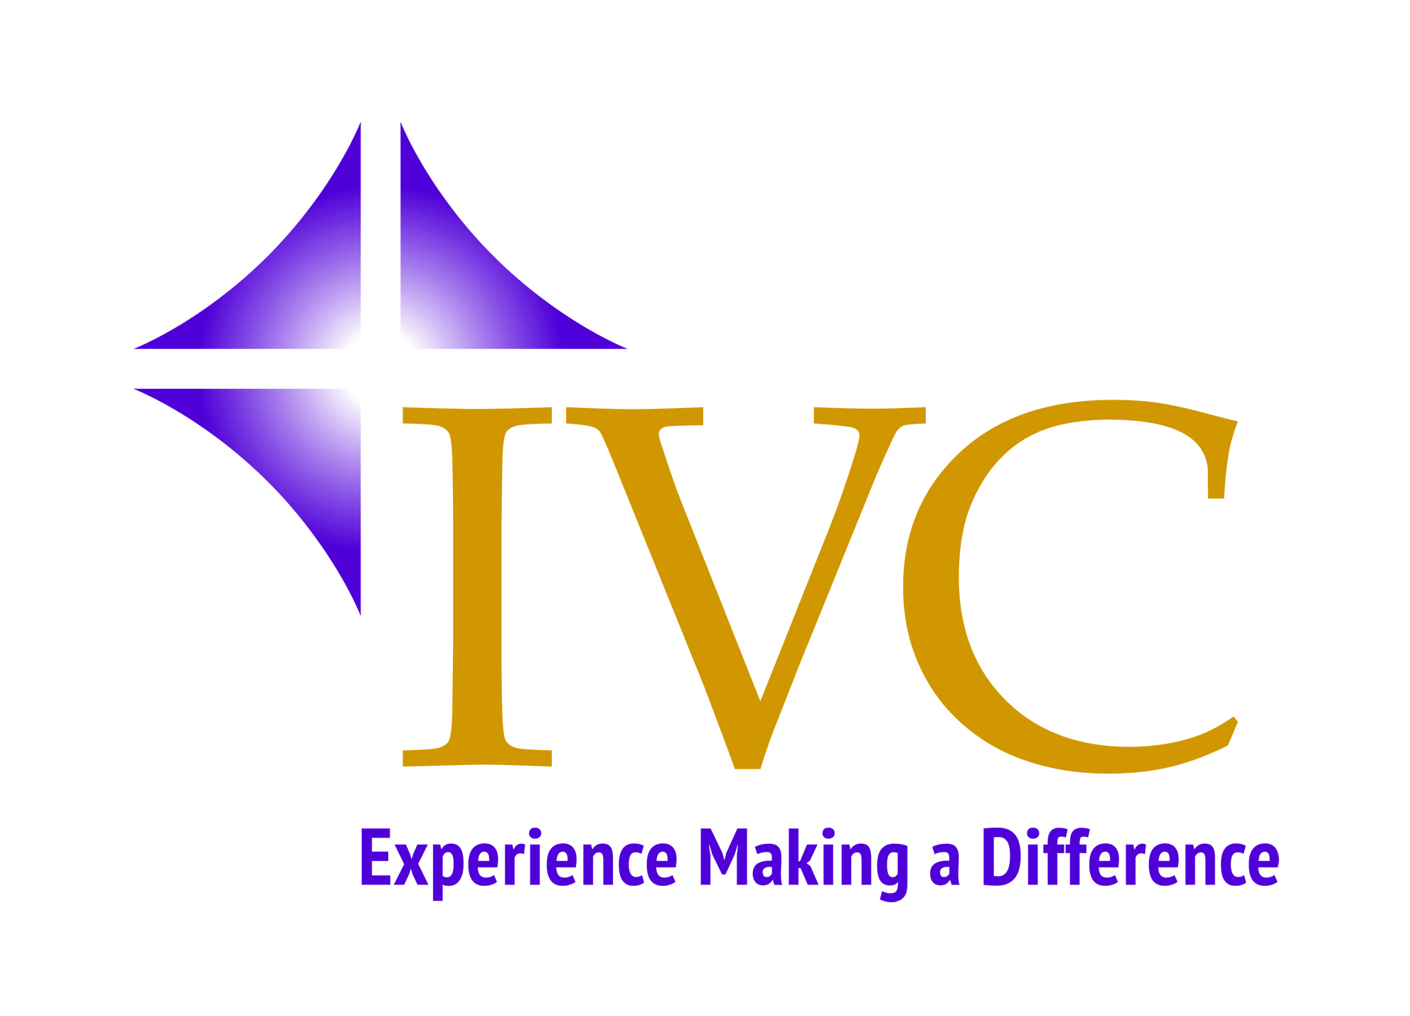
Application for Camino Ignaciano Pilgrimage

General Information:
Name:
Address:
City: State: Zip:
Home Phone: Work Phone:
Cell Phone: Email:
(Please check which of the above is your preferred means for contacting you.)
When is the best time to reach you?
What is your relationship with IVC?
Ignatian Volunteer Regional Advisory Council Member
Spiritual Reflector Board Member
Staff Member Friend/Benefactor

Traveler Information:
Passport ID Number:
Primary Emergency Contact:
Relationship:
Primary Contact’s Phone Number:
Alternate Emergency Contact:
Relationship:
Alternate Contact’s Phone Number:

To help us help you prepare for your pilgrimage, please spend some time reflecting on and answering the following questions.

Naming your desire: In a few sentences, please share a bit about your desire to make this pilgrimage. What do you hope to gain? What concerns do you have?

Practicing self-care: This pilgrimage has been modified a bit to meet the needs of participants of a certain age (including luggage transfers each day, and some bus/train travel to shorten the more difficult sections of the route). Nevertheless, following in the footsteps of St. Ignatius means stepping outside of one’s comfort zone, which becomes a source of spiritual growth. Sleeping accommodations will include everything from double rooms at two-star hotels to bunk beds in a big pilgrims’ shelter. Please share briefly an example of how you generally handle being beyond your comfort zone. How do you react. What do you do to restore equilibrium?

Camino Commitment:
By submitting this application, I agree to the following commitments:
- I will be responsive to communication from IVC and will honor any deadlines requested, including payment deadlines.
  - For the fall Camino, this includes $750 (one quarter) with application by Jan 10; $750 (one quarter) by April 10; and balance (one half—based on euro exchange rate at the time) by July 10, 2020.
  - For the spring Camino, this includes $750 (one quarter) with application by August 10, 2020; $750 (one quarter) by November 10, and balance (one half—based on euro exchange rate at the time) by February 10, 2021.
- I will participate in pre-Camino formation opportunities as they are offered. (This may include in-person local gatherings, conference calls and/or meetings through Microsoft Teams.
- On the Camino, I will be attentive to and take responsibility for my own physical, emotional, and spiritual well-being.
- I understand that a pilgrimage is a spiritual undertaking, not a travel destination. I will engage the prayer and reflection material offered to me, and give my fellow pilgrims the space to do so as well.
- For IVC Staff and Members of IVC’s Service Corps: By submitting this application I certify that I have discussed this with my Director/Placement Supervisor (insert name) ________________________________ and have an articulated plan to cover my work.
- Throughout this process IVC may take photos for marketing purposes. Please check that you agree with the following statement:

I hereby grant my consent to the Ignatian Volunteer Corps copyright and publication rights of my photograph and image. I understand that this photo may be used in multiple media including; print, video, and website media. I further grant the Ignatian Volunteer Corps, its assignees, contractors, licensees, sponsors, and transferees the right to print my name with the photograph/image.

Name: Date:

Please mail or email this completed application to:
Steve Eberle 410-752-4686
Ignatian Volunteer Corps
112 East Madison St. seberle@ivcusa.org
Baltimore, MD 21202

